14. Data Migration Tools - Data Import Wizard - 14 March 2022

Data Migration Tool is used to process bulk records. (Insert, Update, Upsert, Delete, Export).

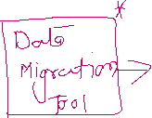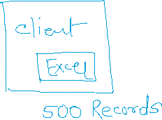

**Data Migration Tools**

1] Data Import Wizard

2] Data Export Wizard

3] Data Loader

4] Workbench

1] Data Import Wizard

**Insert**

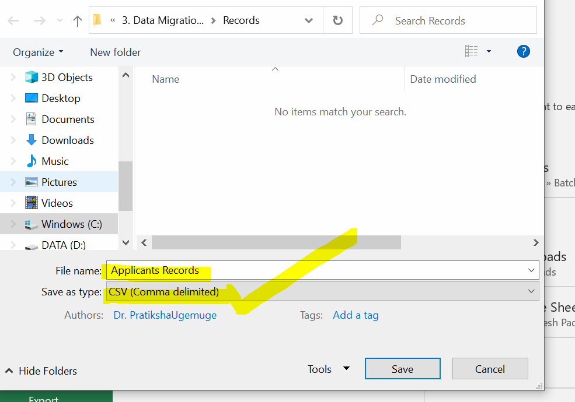

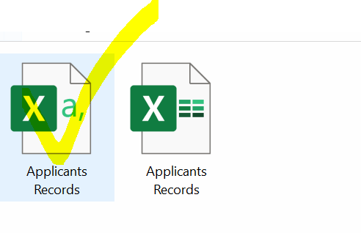

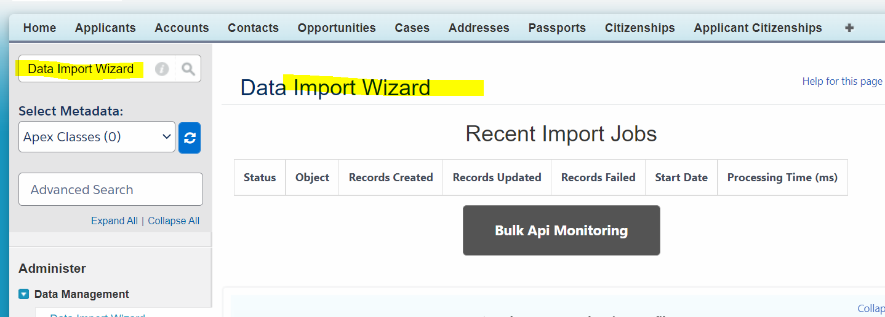

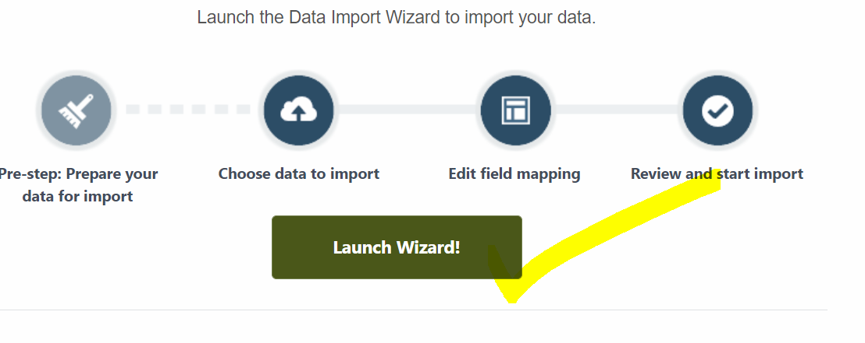

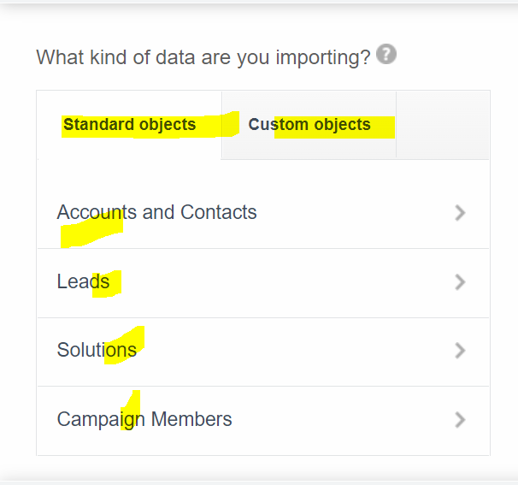

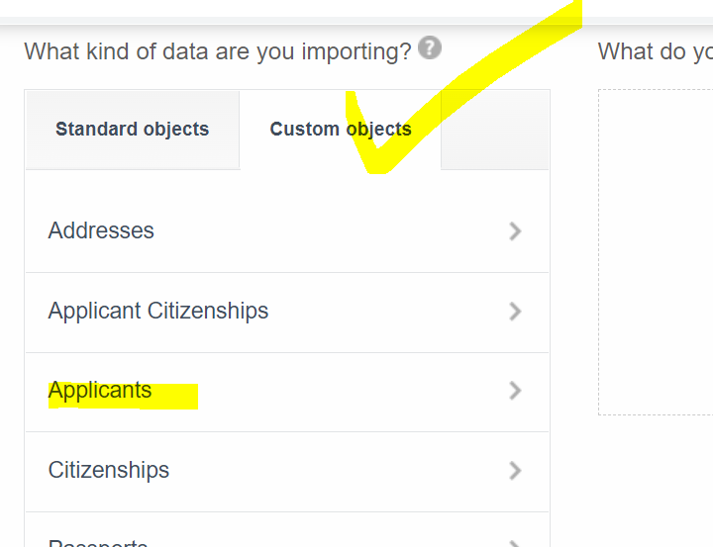

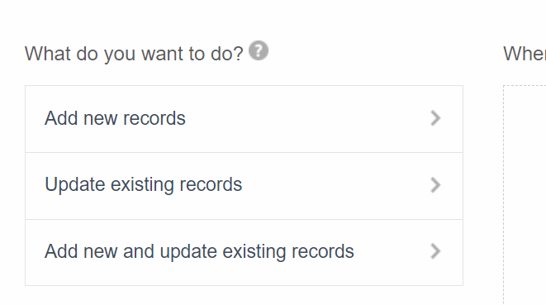



**Shortcut key 🡪 Window + Left Arrow Button**

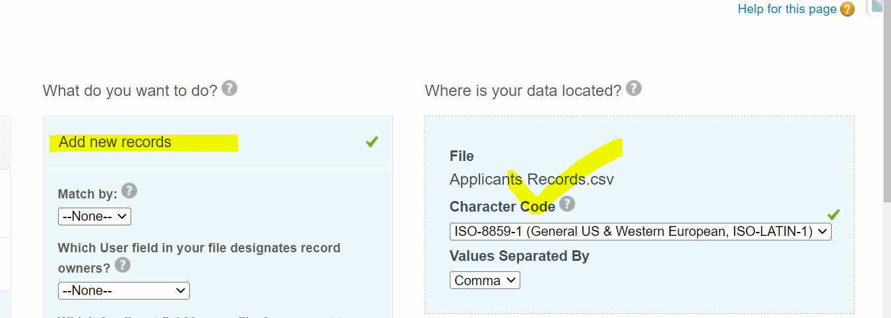

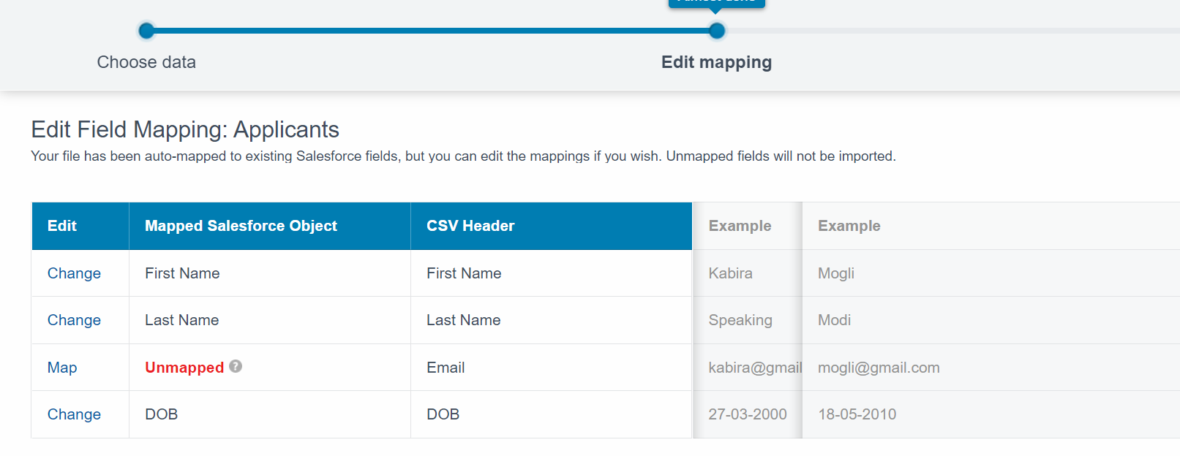



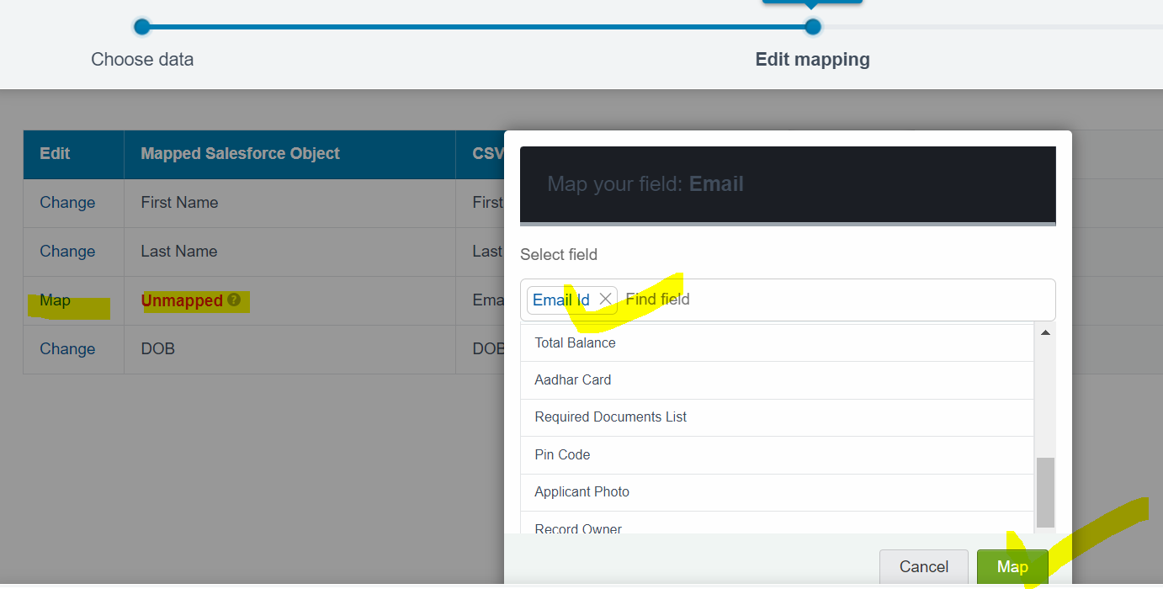

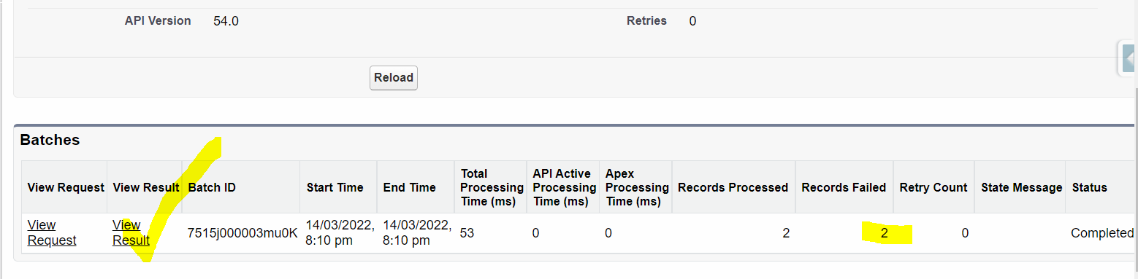

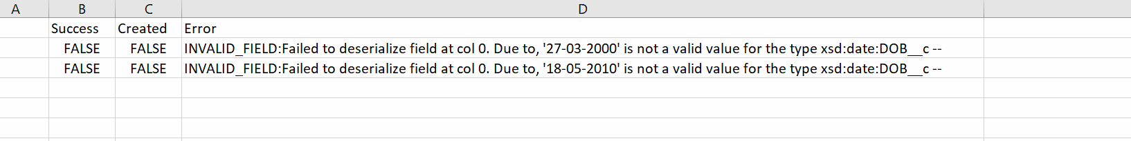



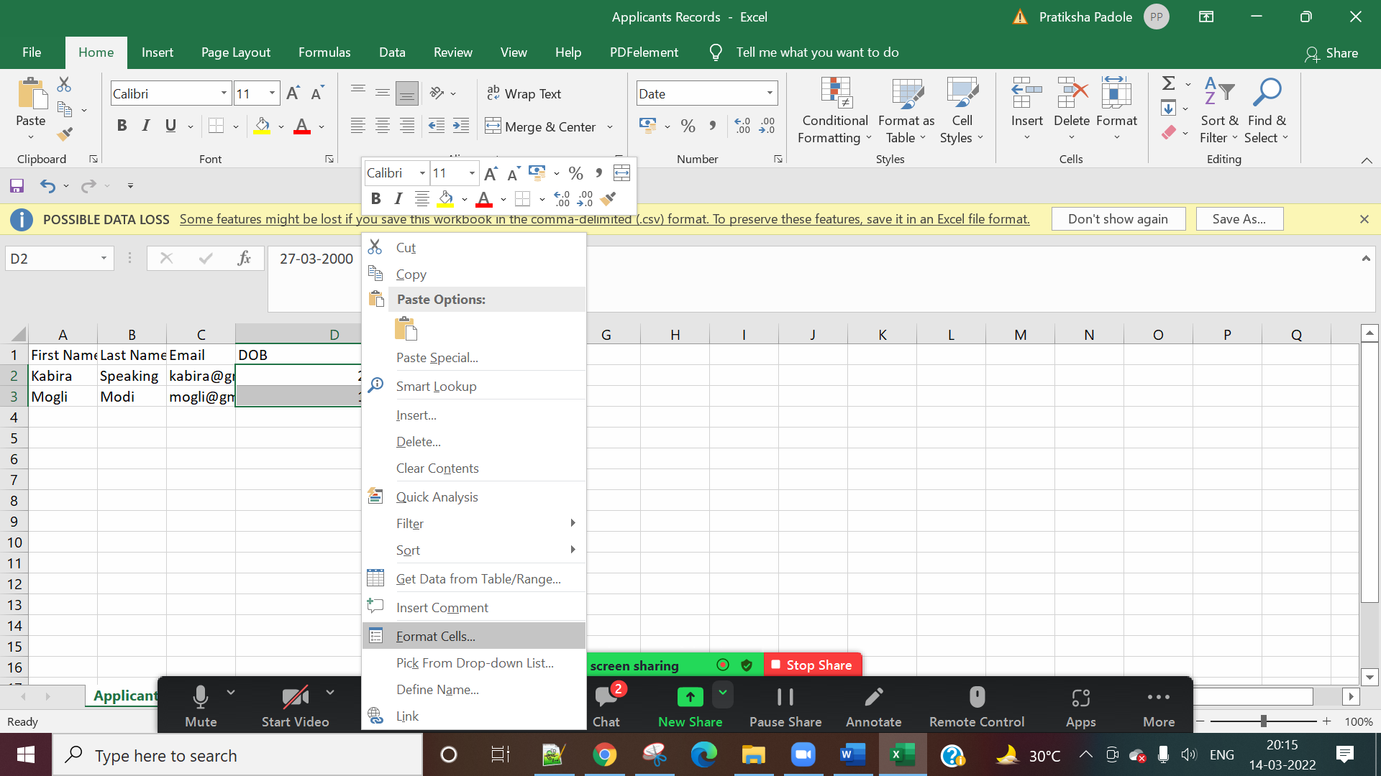

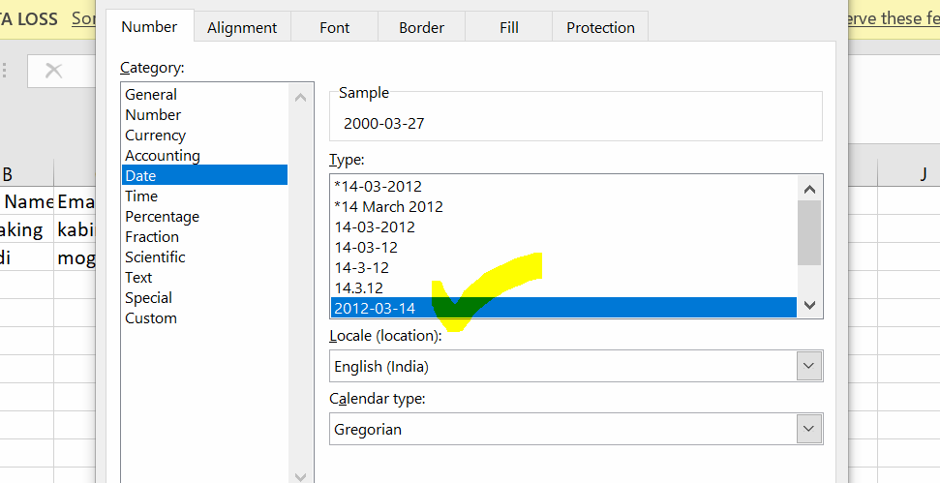

**Update**

Record ID / Reference Id = a005j00000AKWje (15 Digits Record ID)

Record ID (External System) = a005j00000AKWjeAAH (18 Digits Record ID)

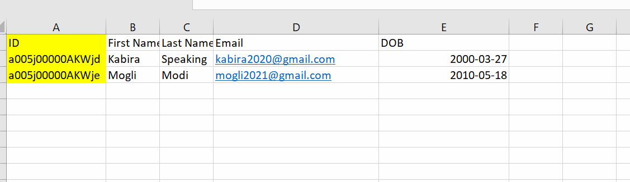

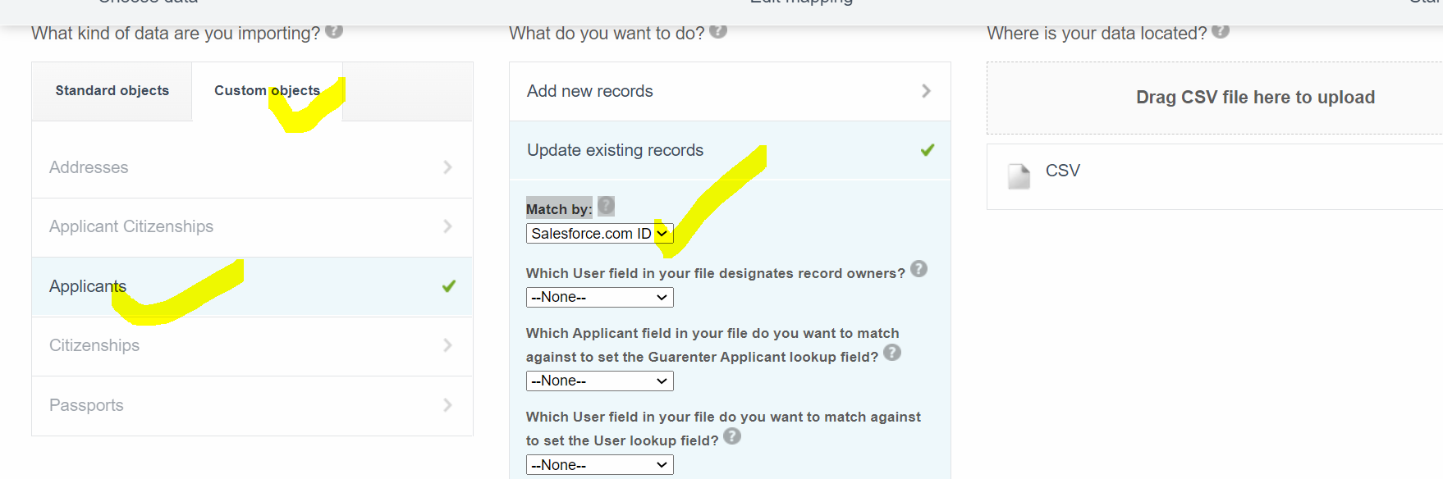

**Upsert (Update + Insert )**

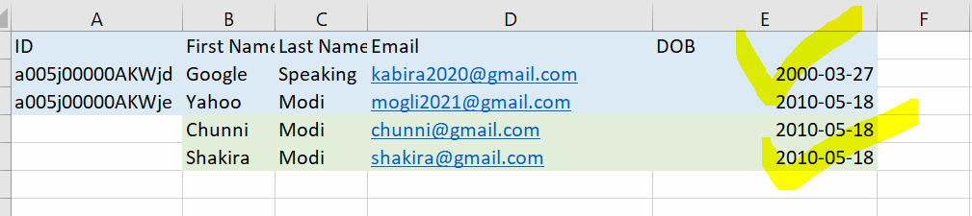

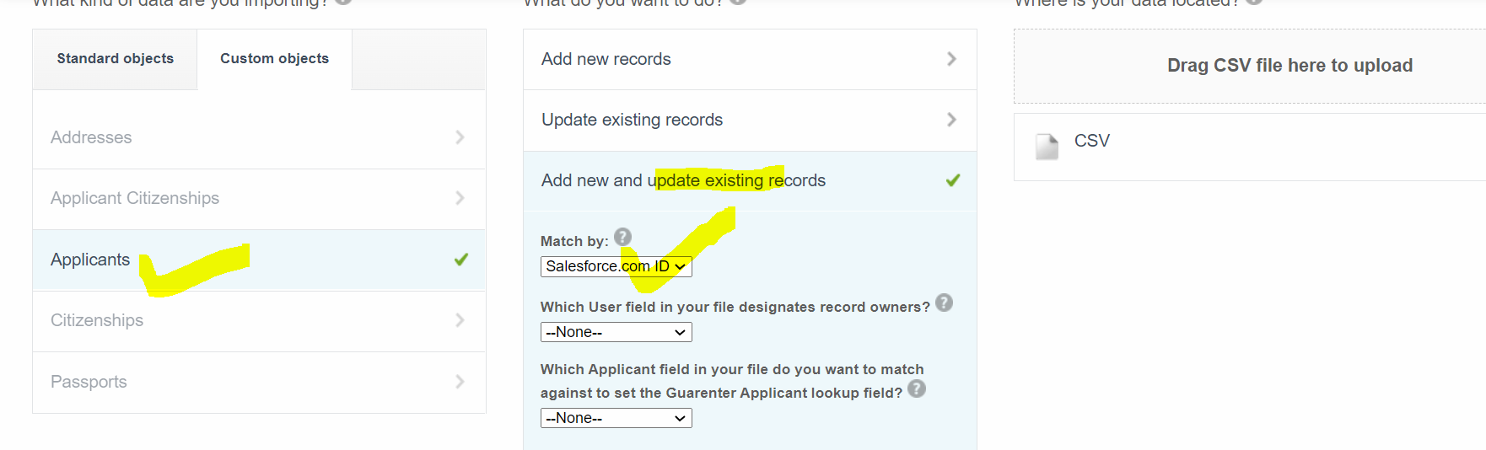

Limitations of Data Import Wizard

1] It supports to only 04 Standard Objects.



2] At a time, we can process maximum 50000 Records.

3] Only Insert, Update, Upsert operations are supported.

Install Data Loader:

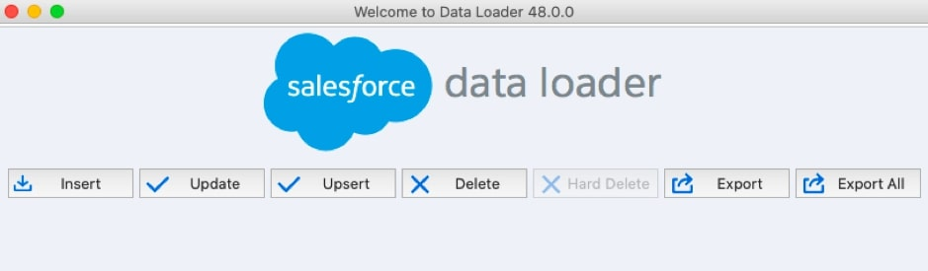

For 64 Bits Operating System:



<https://developer.salesforce.com/docs/atlas.en-us.dataLoader.meta/dataLoader/loader_install_windows.htm>

https://www.azul.com/downloads/?os=windows

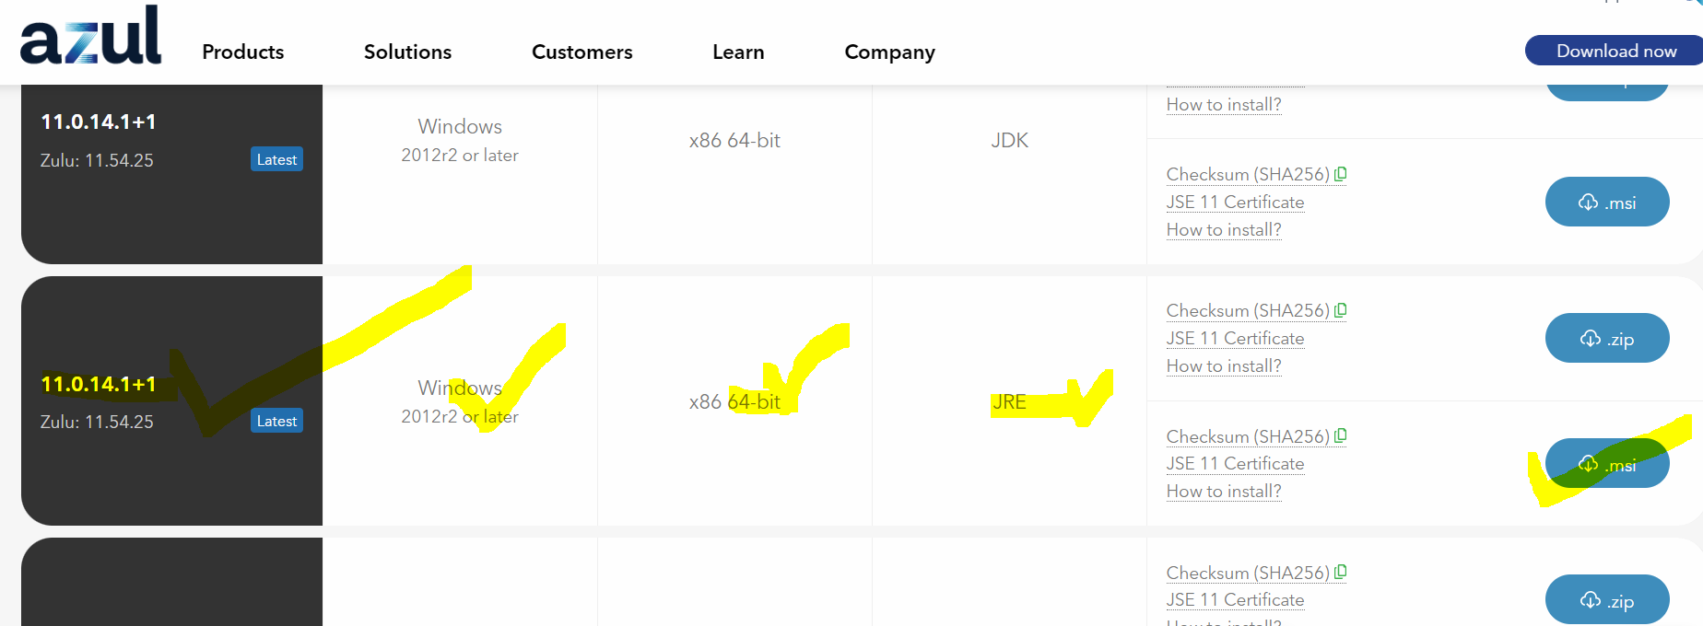

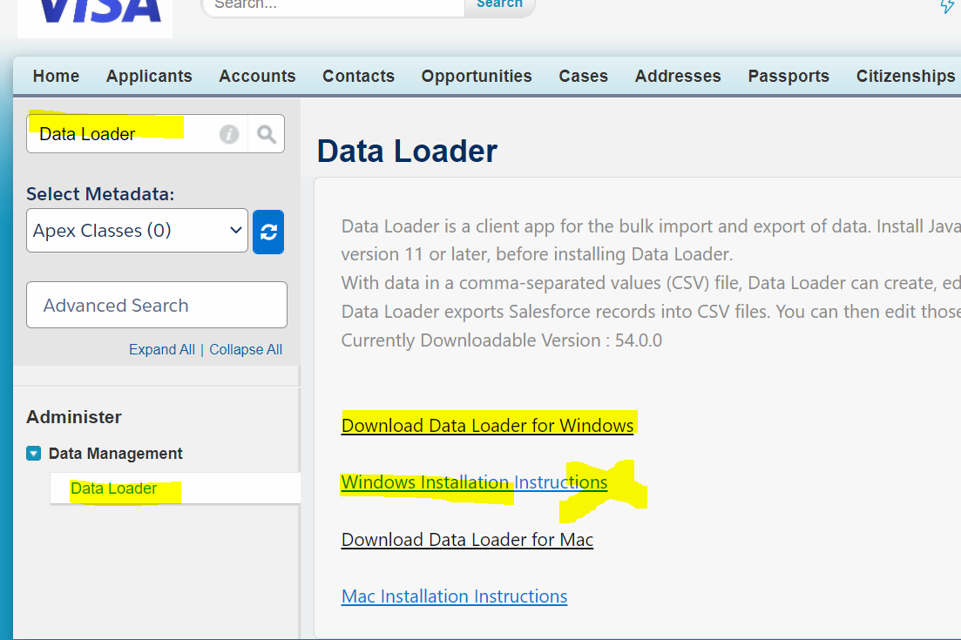

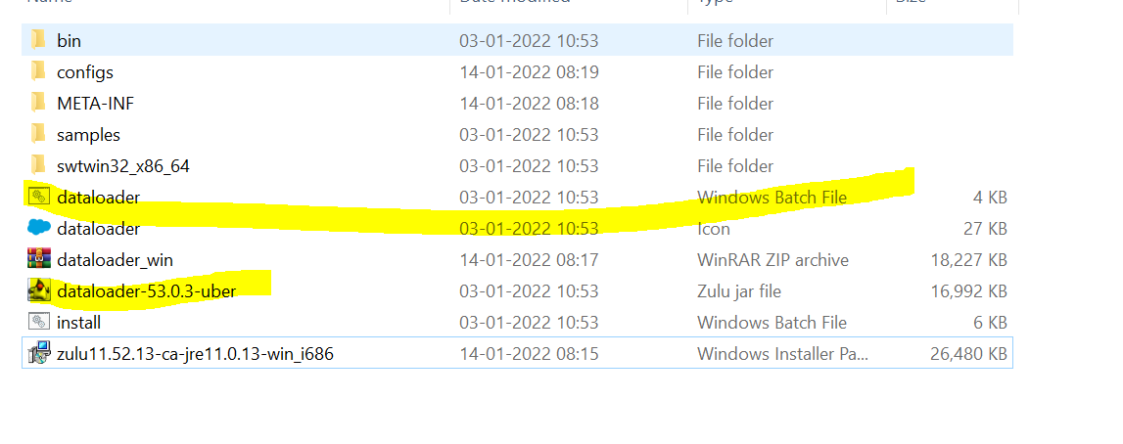

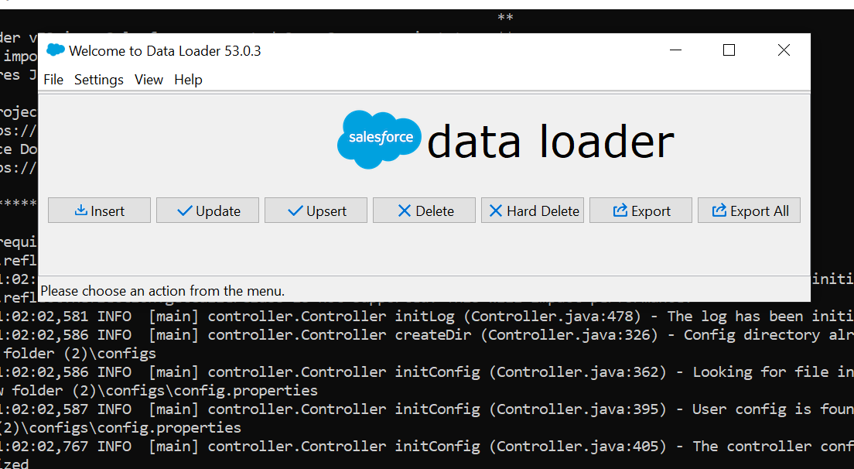

For 32 Bits Operating System

<https://silvermicrosystems.com/DataLoader/>

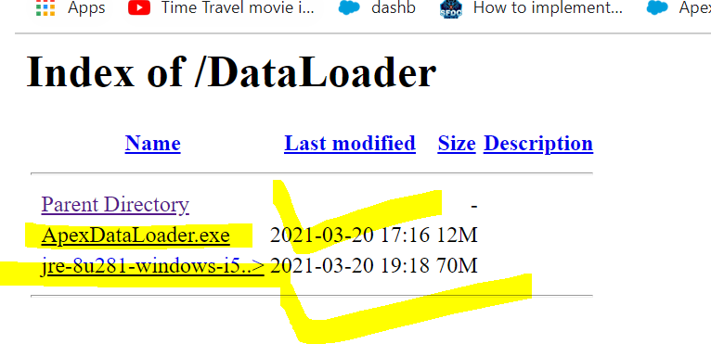

2] Data Export Wizard

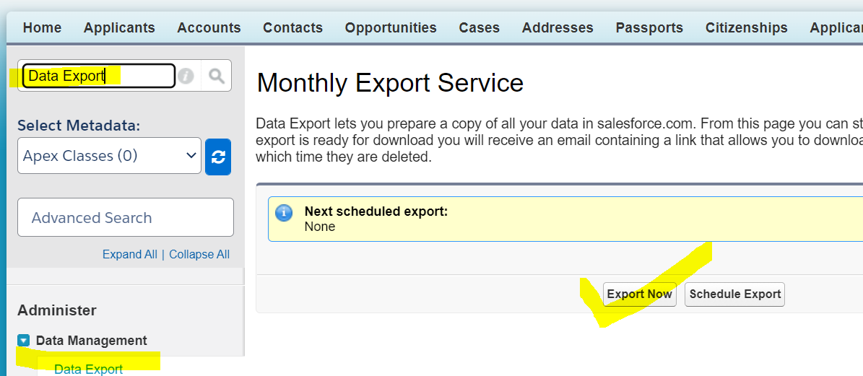

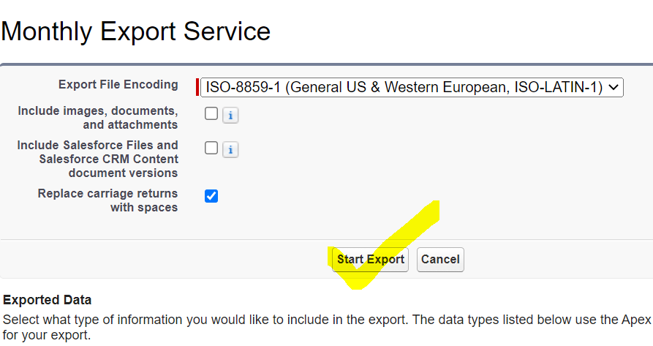

Linux Data Loader:

<https://stackoverflow.com/questions/4303024/apex-data-loader-in-linux-environment>